Mathematical thinking through woodwork

Many of the mathematical concepts that children need to develop in the early years can be developed at the woodwork bench. Much of the mathematical learning that takes place is coincidental, occurring as children resolve practical problems. It is a natural, authentic way for children to develop their mathematical knowledge and understanding. It provides a wonderful way for us to observe and extend children’s mathematical thinking.
There are endless opportunities to explore numeracy and shape, space and measure. Many mathematical concepts are involved, including matching, classification, counting, measuring, proportion, comparison, size, weight and balance, and two and three dimensional shapes.
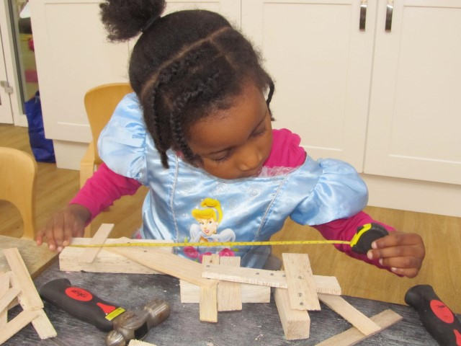

Numeracy
Woodwork will encourage the spontaneous use of number names and number language. Children will be able to represent numbers with objects (for example, the number of nails or screws). This encourages them to match numeral and quantity. Counting quantity, for example the number of sections of wood used, gives opportunities to work towards exploring numbers up to 20 and concepts such as one more and one less. There are opportunities to sort the various types of materials being used. Children can count out from a larger quantity, for example counting 6 nails from a tub full of hundreds of nails.
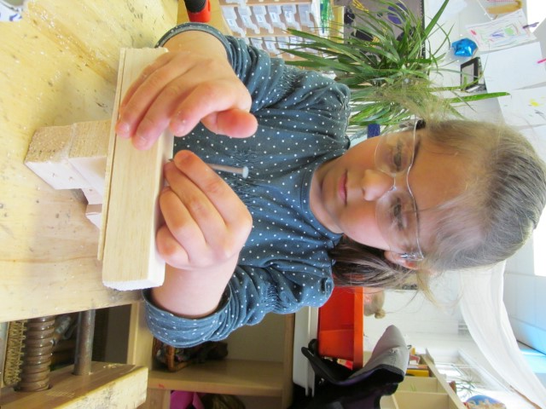
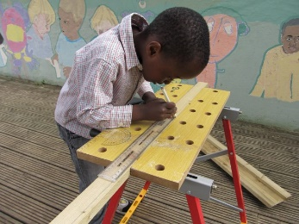
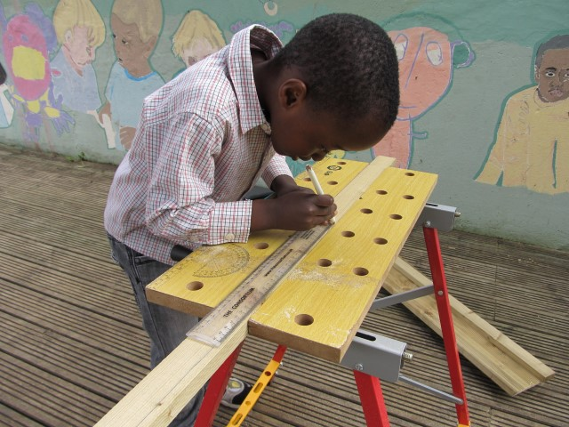

There are opportunities for speculation and estimation and then for checking by counting. Numbers can be associated with length, for example with the use of the tape measure. Basic mathematical concepts such as adding and subtracting come into play as wood is joined or screws removed. There are opportunities to explore concepts such as halving and doubling by cutting wood in two or joining to equal sections. There are also many opportunities for mathematical problem-solving as the children work out how to use the resources effectively to express their imagination, for example working out how deep to drill a hole.
Shape, space and measure
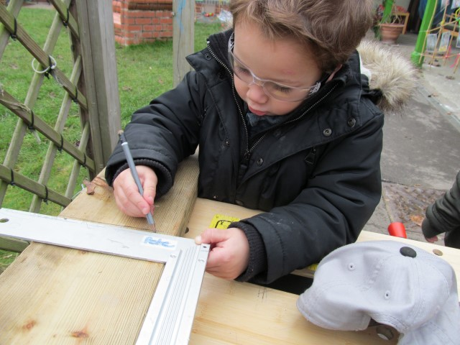

Woodwork also provides many opportunities to explore shape, space and measure. Woodwork encourages three-dimensional thinking as children work with shape and create arrangements, developing an understanding of the properties of shapes, angles and spatial relationships. They notice sides, corners, edges, round, square, oblong, rectangle, circle, triangle. Their understanding develops as they identify, name and describe these shapes and properties.
There are many opportunities to explore and compare size: big, small, little, large, short, long, thin, wide, thick, and narrow, and these concepts can be further explored with the use of a basic measure. Concepts of weight and height are discussed: heavy/light; tall/short; high/low. Line can be explored: straight/curved; sides/corner; flat/angle; surface/edge. Children encounter spatial thinking in terms of orientation and position: upright/vertical; horizontal/sloping; under/above; behind/next to. There are many opportunities to categorise, sort and compare according to the shape and size.
Estimating is often involved in woodwork, for example, thinking about the best length of nail to use to join two sections of wood together. Understanding of measure can be supported by using a variety of measuring devices and using different units, including non-standard units. The more opportunities children have to measure for a real purpose the better. This is learning in context.
Extending mathematical thinking
Our role as a teacher in extending thinking is very much about tuning in and showing genuine interest in children’s work and noticing when they are using mathematical thinking skills, and to then to encourage and develop these. This way our interventions are relevant and have meaning. We need to encourage mathematical problem-solving by asking open-ended questions to support children’s learning. Incorporate number language into your interactions, count in a variety of different situations and expand their numeracy vocabulary by using words such as less, fewer etc. We can encourage the children to speculate in various situations, for example, estimating the age of a tree section and then checking by counting the rings.
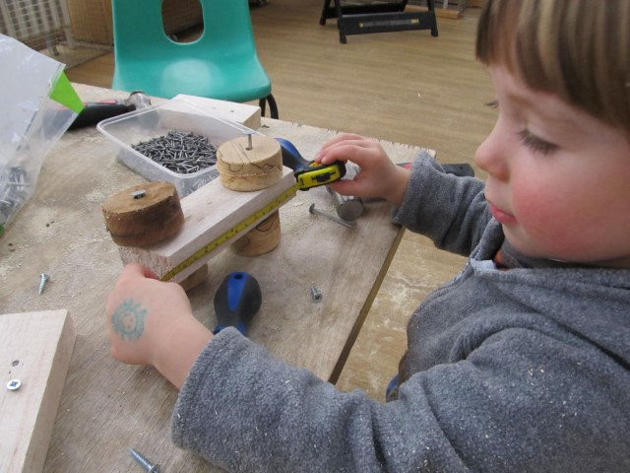

Resources:
Have pen and paper available to allow children to represent their mathematical thinking through graphics. Encourage them to take some photographs of their emerging models at different stages so they can reflect on the mathematical concepts they have explored.
Also provide: fabric tape measures, rulers, folding rulers, set square, scales, children’s camera, different sized tree rings, screws and nails in a variety of lengths, wood in a variety of shapes and sizes, including circles.

Pete Moorhouse www.irresistible-learning.co.uk

