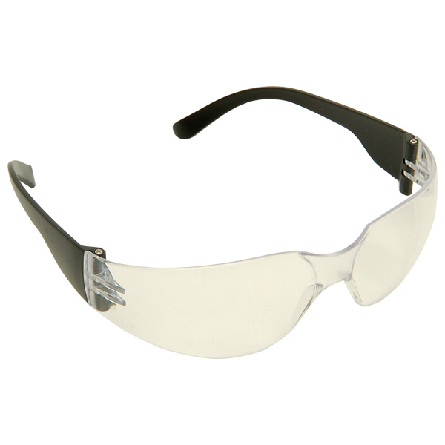Woodwork in Early Years Eduaction
Pete Moorhouse www.petemoorhouse.co.uk

Safety Glasses

For many years I made the decision that children were encumbered by wearing safety goggles – which often actually restricted their vision leading to a higher likelihood of an accident. I also found children were uncomfortable wearing goggles and spent much time fiddling with the goggles, repositioning etc. which resulted in a diminished experience of woodwork.
Attitudes to eye protection for children’s woodwork vary around the world – in the USA they would always be worn in countries such as New Zealand, Japan and Scandinavia they are not used.
My current advice to all practitioners working in the UK is to have children wear safety glasses.
Small fitting safety glasses are now readily available. These are wonderful – they are comfortable to wear and the children forget they are wearing them – often wondering off still wearing them at the end of the session!
When working with balsa wood there is not an issue but as soon as children move on to other slightly harder woods there is a chance that a nail could rebound – thus impact in the eye. This is possible with soft woods although more likely with hard woods and MDF. Soft woods have knots which are just as hard as hard wood. A nail can rebound if it is hit at an odd angle and the wood is resistant.
By wearing safety glasses this eliminates this small area of risk.
I also believe that if we think children are old enough to do woodwork then there are also old enough to learn about basic safety culture and taking responsibility for their own body and protecting themselves.
So I now advocate safety glass be worn at all times. In my experience the children have been very positive about this and enjoy wearing them. Teacher also always to wear a pair.

There are many suppliers out there. The one I use is:
Rapid Electronics - JPS Junior 7000 spectacles from: www. rapidonline.com
http://www.rapidonline.com/facilities/junior-laboratory-spectacles-72695
Also from http://www.thesafetysupplycompany.co.uk/

Any comments/ feedback to studio@petemoorhouse.co.uk

04-02-2015 Pete Moorhouse

