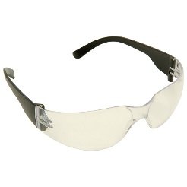  Junior Safety Glasses | Approx £2 each  --------------  Essential item | www.cosydirect.com  Rapid Electronics- JPS Junior spectacles  http://www.rapidonline.com/facilities/junior-laboratory-spectacles-72695  http://www.thesafetysupplycompany.co.uk
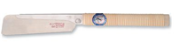  Small dozuki Japanese saw 160mm | Approx £25  --------------  Essential item | http://www.amazon.co.uk/JAPANESE-SMALL-DOZUKI-TENON-PANEL/dp/B00BO7LKY8/ref=sr_1_2?ie=UTF8&qid=1458816045&sr=8-2&keywords=japanese+ice+bear+160  alternative option available from  www.cosydirect.com
Larger Pull saw – for cutting through thicker wood  CON:P 265mm by CONMETALL, Germany  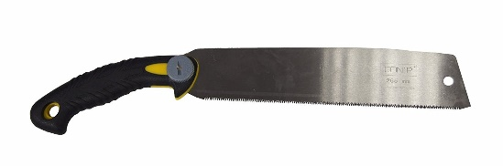 | Approx £10  Either this saw or one below | https://www.amazon.co.uk/gp/product/B00FL8S6IO/ref=oh_aui_detailpage_o07_s01?ie=UTF8&psc=1
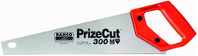  European style cross-cut saw:  Bacho Tool box saw | Approx £10  Either this saw or one above | https://www.amazon.co.uk/Bahco-300-14-F15-16-Hp-Toolbox-Handsaw/dp/B0001GS12C/ref=sr_1_2?s=kitchen&ie=UTF8&qid=1462526216&sr=1-2&keywords=bacho++saw  www.cosydirect.com
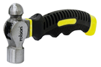  8oz Stubby Ball Pein Hammer | Approx £5 each  Essential item | http://www.muddyfaces.co.uk/product/__trashed-2/  https://www.amazon.co.uk/Rolson-10021-Stubby-Ball-Hammer/dp/B001KOTNFI/ref=sr_1_4?s=kitchen&ie=UTF8&qid=1462526311&sr=1-4&keywords=stubby+hammer  www.cosydirect.com
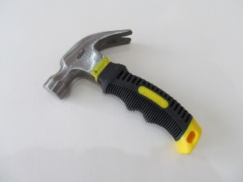  8oz Stubby C law hammer | Approx £5  Useful to have one – for removing nails | www.cosydirect.com  http://www.muddyfaces.co.uk/product/claw-hammer-8oz-stubby/
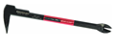  Japanese nail puller | Approx £15  Useful tool for removing nails | https://www.amazon.co.uk/Vaughan-Bear-Claw-Puller-195mm/dp/B001D1H9S6/ref=pd_sim_sbs_60_3?ie=UTF8&dpID=31sRYQJOA-L&dpSrc=sims&preST=_AC_UL160_SR160%2C160_&refRID=91GC87R2RJW8QF45963E
Nail puller  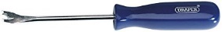 | Approx £5  Useful tool for removing nails | https://www.amazon.co.uk/Draper-64804-195-Tack-Lifter/dp/B0001K9ZAK/ref=sr_1_7?s=diy&ie=UTF8&qid=1507281081&sr=1-7&keywords=nail+puller
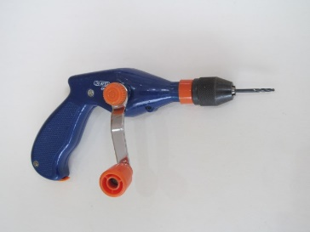  Draper pistol grip hand drill | Approx £15 each  Essential item | www.cosydirect.com  http://www.muddyfaces.co.uk/product/pistol-grip-hand-drill/
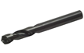  Short stubby drill bits | £5 for 10  Very useful - being short less likely to break | http://www.ebay.co.uk/itm/DeWalt-HSS-Stubby-Drill-Bits-Pack-Of-10-Size-3-3-mm-/281671989573?hash=item4194f57945:m:m-5kVlFz-_y1AuH2y3kqiRQ
Brace and bit  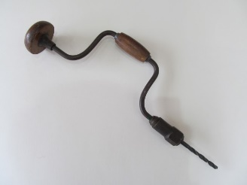 | £10  Makes drilling larger diameter holes easier | www.cosydirect.com  http://www.muddyfaces.co.uk/product/wooden-hand-drill/
Misc. Measuring equipment  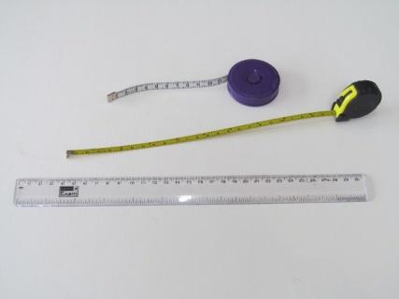 | Also a spirt level can be a nice addition | http://www.muddyfaces.co.uk/product-category/tools-storage/measures-levels/
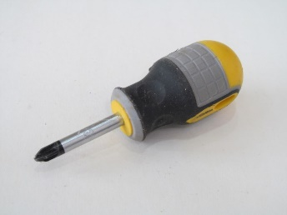  Short posidriv screwdriver PZ2 | Approx £2 each  Essential item | www.cosydirect.com
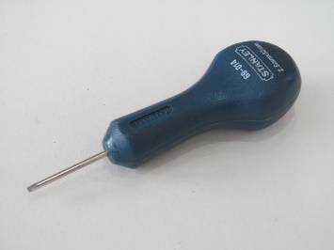  Stanley bradawl | Approx £5  Useful to make hole in balsa prior to screwing | https://www.amazon.co.uk/Stanley-STA069014-1-1-3In-0-69-014/dp/B0001IW7SO/ref=sr_1_6?s=diy&ie=UTF8&qid=1507283198&sr=1-6&keywords=bradawl
Palm drills  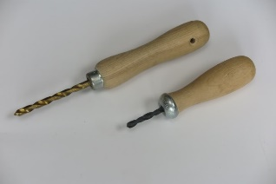 | £3 | http://www.muddyfaces.co.uk/product/palm-drill-standard/  www.cosydirect.com
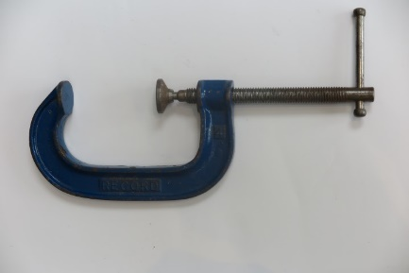  G Clamps | £5 | Available from all hardware suppliers.  www.cosydirect.com
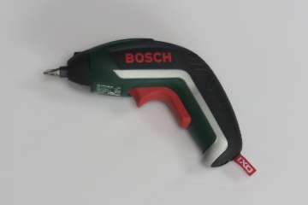  Battery powers screwdriver | Approx £25 each | https://www.amazon.co.uk/Bosch-Cordless-Screwdriver-Integrated-Lithium-Ion/dp/B00XI610R0/ref=sr_1_1?s=diy&ie=UTF8&qid=1507284594&sr=1-1&keywords=bosch+battery+screwdriver
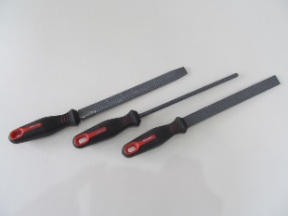  Rasps | Approx £12 | https://www.amazon.co.uk/Silverline-MS104-Rasp-Set-3-Piece/dp/B000LFTQVI/ref=sr_1_2?s=diy&ie=UTF8&qid=1507284624&sr=1-2&keywords=rasps
Large magnet  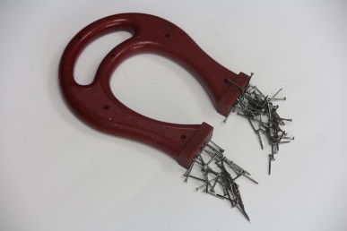 |  | All educational suppliers  www.cosydirect.com
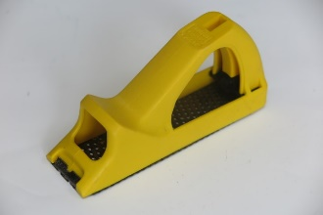  Surform |  | https://www.amazon.co.uk/Stanley-Moulded-Surform-Block-521104/dp/B0001IWCUC/ref=sr_1_1?s=diy&ie=UTF8&qid=1507284745&sr=1-1&keywords=surform
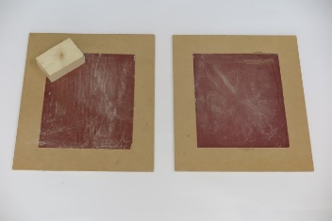  Sandpaper | Approx £2 each | Sheets available from all hardware supplier – glue to a board for easy use
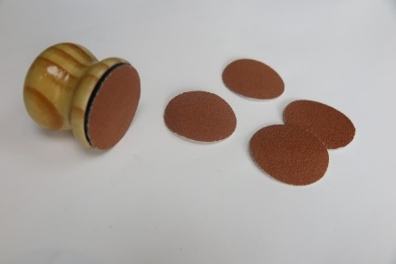  Sanding discs | Approx £5 | http://t4kids.co.uk/
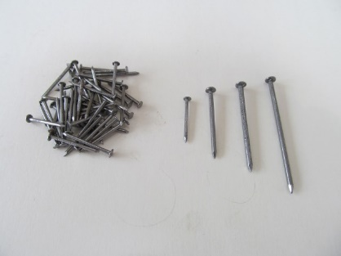  Nails |  | 25mm round nails with a head. These are a perfect size to use with the balsa wood and are easy to hold and great to gain confidence with. 25Kg boxes work out very economical in the long run.  Also 40mm, 50mm and 65mm lengths and 2.65mm width. Bright round nails (cheaper than galvanised)  https://www.rjpryce.com
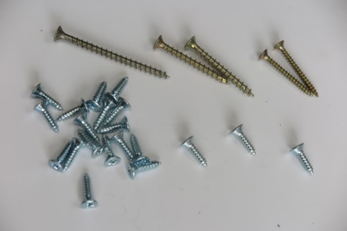  Screws |  | We start with small screws. No 10’s, ¾ inch are perfect, to make the task relativity easy and so develop confidence. Always use cross head screws as they are much easier than slotted screws. Size: PZ2  As children’s skills develop a selection of longer screws can be introduced.  https://www.rjpryce.com
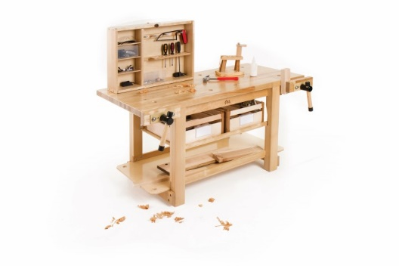  Workbench | £610 | Community Playthings  sales@communityplaythings.co.uk  Telephone 0800 387 457 (UK only) +44 (0)1580 883310
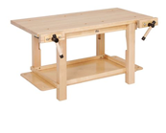  Workbench | £340 | Community Playthings  sales@communityplaythings.co.uk  Telephone 0800 387 457 (UK only) +44 (0)1580 883310
Workbench  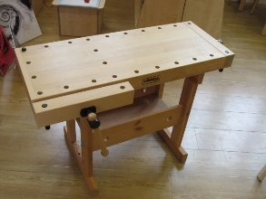 | £342 | Early Excellence  http://earlyexcellence.com/go-shopping/woodwork-bench-large-continuous-provision-3-7yrs/
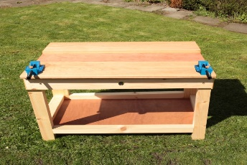  Workbench | £210 | http://www.cosydirect.com/woodwork-bench.html  https://www.creativecascade.co.uk/products/wood-works/
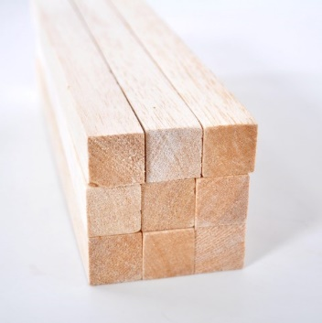  Junior Safety Glasses | Essential for first sessions | I recommend starting with lengths of 25mm by 25mm box sections  The Balsa Cabin balsacabin@hotmail.com 01621 859711  Fred Aldous sales@fredaldous.net 0161-2364224  www.cosydirect.com
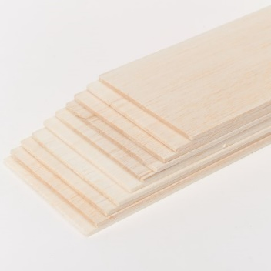  Small dozuki Japanese saw | Essential for first sessions | I recommend starting with lengths of thin sheets 3mm or 4mm ( 1/8” or 3/16”) that can be prepared into smaller sections  The Balsa Cabin balsacabin@hotmail.com 01621 859711  Fred Aldous sales@fredaldous.net 0161-2364224  www.cosydirect.com
PORTABLE BENCH VICE  Senator.60mm PORTABLE BENCH VICE  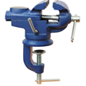 | £20 | https://www.cromwell.co.uk
Stanley 0-83-179 Quick Vice  From amazon and many others  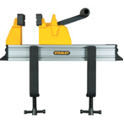 | £25 | https://www.amazon.co.uk/Bahco-300-14-F15-16-Hp-Toolbox-Handsaw/dp/B0001GS12C/ref=sr_1_2?s=kitchen&ie=UTF8&qid=1462526216&sr=1-2&keywords=bacho++saw

Woodwork Equipment
For detailed advice on how to safely use tools with young children- see the book:
Learning through woodwork: Introducing creative woodwork in the early years by Pete Moorhouse
To get started you will need a basic toolkit. Having the right tools does make a big difference, for example a hammer with a short handle with good grip, and a reasonable weight with a large head would be excellent however a long handled pin hammer will make the tasks more difficult leading to frustration. Over the years we have refined which tools are most suitable to young children. I don’t supply tools and at present there is no shop that sells all the recommended tools – so it will take some effort to source from the different suppliers – but it will be worth it.
A starter kit should include: hammers, screwdrivers, a saw, a hand drill and drill bits, workbench and lots of nails and screws.
Work surface: An old table at child height would make a good work surface or alternatively a table could be covered with a sheet of wood to protect the surface. Wood being sawn or drilled needs to be held firm. A study heavy workbench with a vice is ideal.
The toolkit can be added to over time as the children’s knowledge and skills develop – woodwork lends itself to slowly adding new skills and tools.
Most of the tools are standard but there are three items I would strongly specifically recommend being particularly ergonomic for young children:
- The 8oz Stubby Ball Pein Hammer as it really is perfectly suited to young children.
- Draper pistol grip hand drill & drill bits. This drill is perfect for young children to hold and the mechanism is enclosed.
- A small Japanese saw is a great addition and very easy for children to use cutting on the back stroke. Ice Bear brand is readily available. Japanese saws generally have teeth on both sides but this model the top edge is smooth.

In addition a larger saw is useful for sawing thicker wood. A larger pull saw or the Bahco tool box saw is useful.
Remember tools can be added to over time – start with the basics
Links to suppliers may change. Please do let me know if any links are broken and then I will update. Thank you. studio@petemoorhouse.co.uk
If you are a supplier and would like to be added please contact me

Pete Moorhouse Oct 17

